People First PPPs

Can People First PPPs become the instrument of partnership to implement the SDGs?

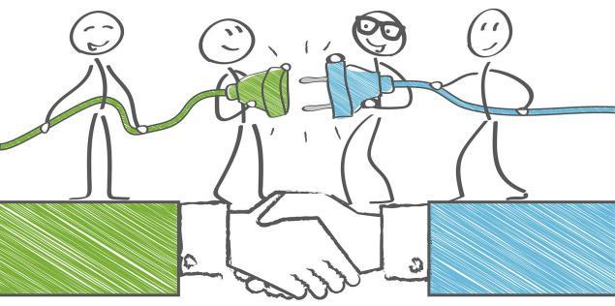

Time & Date:

Venue: KICC, Nairobi

Organised by CUTS Institute for Regulation & Competition

Background
The interest generated by the role of PPPs in the implementation of the Sustainable Development Goals (SDGs) is considerable. SDG 17, for example calls for the revitalisation of the global partnership for sustainable development and expressly for: “Partnerships: public, public-private and civil society”. Indeed PPPs and the SDGs are and should be aligned with each supporting the other, this is the basis of Goal
17.

PPPs till recently were considered as a financial tool for transferring project and financial risk to private sector while the state retained the sovereign risk. It was not viewed as a “development model” but rather a value for money alternative to traditional public procurement. Although in India the model has been used to introduce private sector efficiencies while retaining public purpose as the driving principle.

Successive governments in developing countries have tried to implement major projects through the PPP route. The greenfield airports, private ports and real estate projects have been some of the highlighted ones. But there has been a chain of problems in the implementation of such projects. Hence it could be said the jury is still out on net benefits from PPPs though it is certain they bring in tremendous value.

The challenge is then to address these problems and overcome them through a set of Guiding Principles that stakeholders in Developing Countries and Least Development Countries could follow in their policies and practice in order to create People First PPPs. A new consensus is needed on the way forward on the People First PPPs model. There is a need to develop a more nuanced and sophisticated model of these partnerships with quick dispute redressal mechanisms.

Against this background, this side event will explore a systematic approach for development of People first PPPs as instrument of partnership in DCs and LDCs to be “fit for purpose” for the development of infrastructure assets and delivery of associate services that would result in “People first outcomes”.

